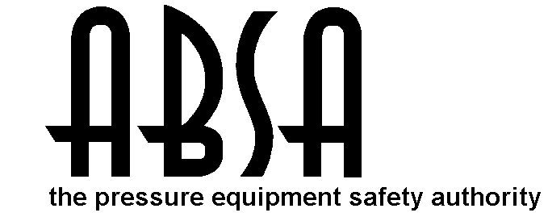

OUT OF PROVINCE

APPLICATION FOR THE GRADE B CERTIFICATE OF COMPETENCY PURSUANT TO THE RECIPROCAL RECOGNITION AGREEMENT

A. I,
(Last Name) (First Name) (Initial)
of ,
(Street Address) (City) (Province & Postal Code)
Home Tel.: Bus. Tel.: Date of Birth: Email:
(YYYY/MM/DD)
do hereby make application to obtain an Alberta Grade “B” Pressure Welder's Certificate under the Safety Codes Act and Regulations, and reciprocal recognition agreement.

- I am the holder of the following Welder's Certificates:
a) Inter-provincial Red Seal Journeyman Certificate (No. #)
b) Recognized Pressure Welder Certificate
Province of Issue: Certificate No.: Expiry Date:

(Signature of Applicant) (Date)

Please submit copies of these documents with this form:
a) Inter-Provincial Red Seal Journeyman Certificate or Welder Trade Certificate
b) Out of Province Reciprocal Pressure Welder Certificate
b) Government issued Photo ID (ie: valid driver’s license)

PAYMENT MADE BY: |  | Cash | M/C | Visa |  | Debit
$177.00 application fee | Card Number: |  |  |  | Expiry Date:
Cardholder Name: Signature:

FOR ABSA USE ONLY File No. W -

Performance Qualification Card details:

Process SMAW SMAW Material P1 to P1
Max Deposited 6 mm 16 mm Min. Pipe Dia. NPS 2 ½
Weld Metal
Filler Metal Group F3 F4 Position Qualified ALL
Backing No Yes Progression Uphill

(Date of Test) (Date of Expiry) (Safety Codes Officer) (Date)

(Administrator/Chief Inspector) (Date)

The information you provide is necessary only for the administration of the programs as required by the Alberta Safety Codes Act and Regulations in the Boiler Discipline.

